PROLONG A NETWORK

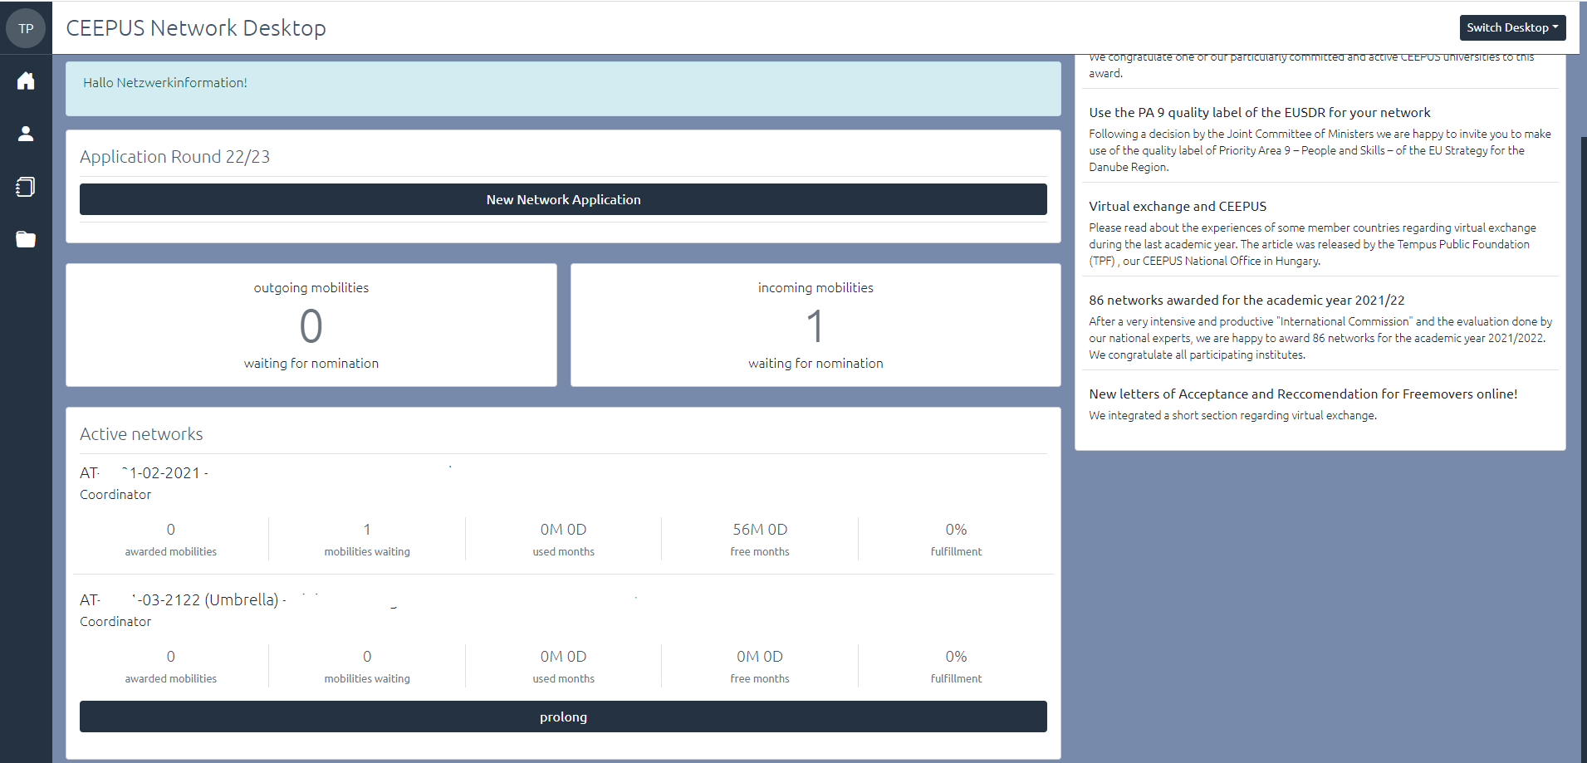
After clicking on the Prolong button please have a look at your partners
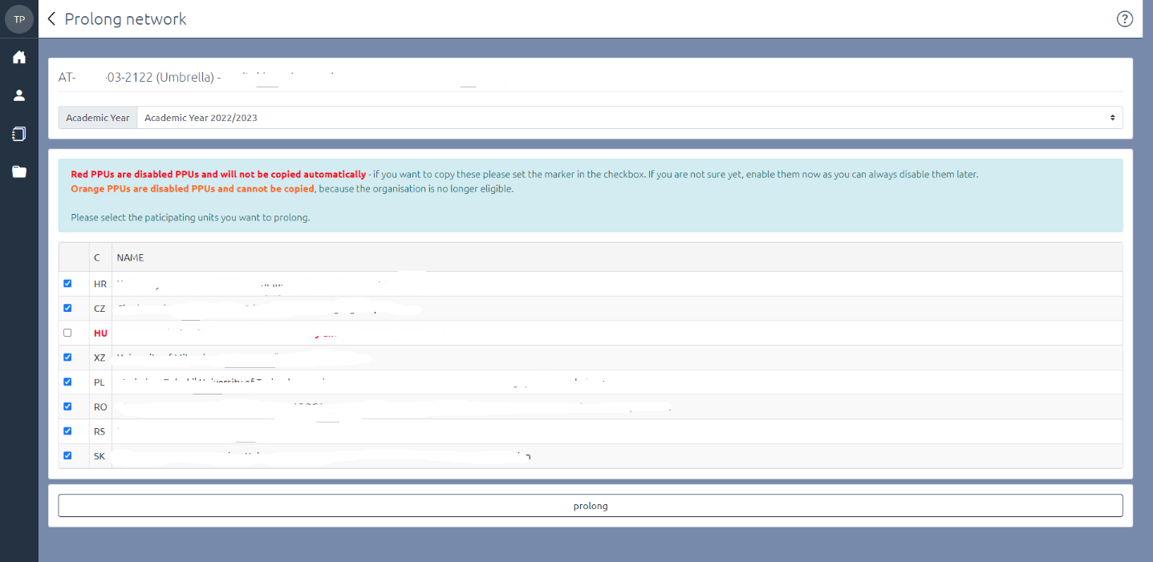

After clicking on the prolong button you will be automatically forwarded to the network overview.
Please fill in the required fields (orange). Not all information will be transferred.
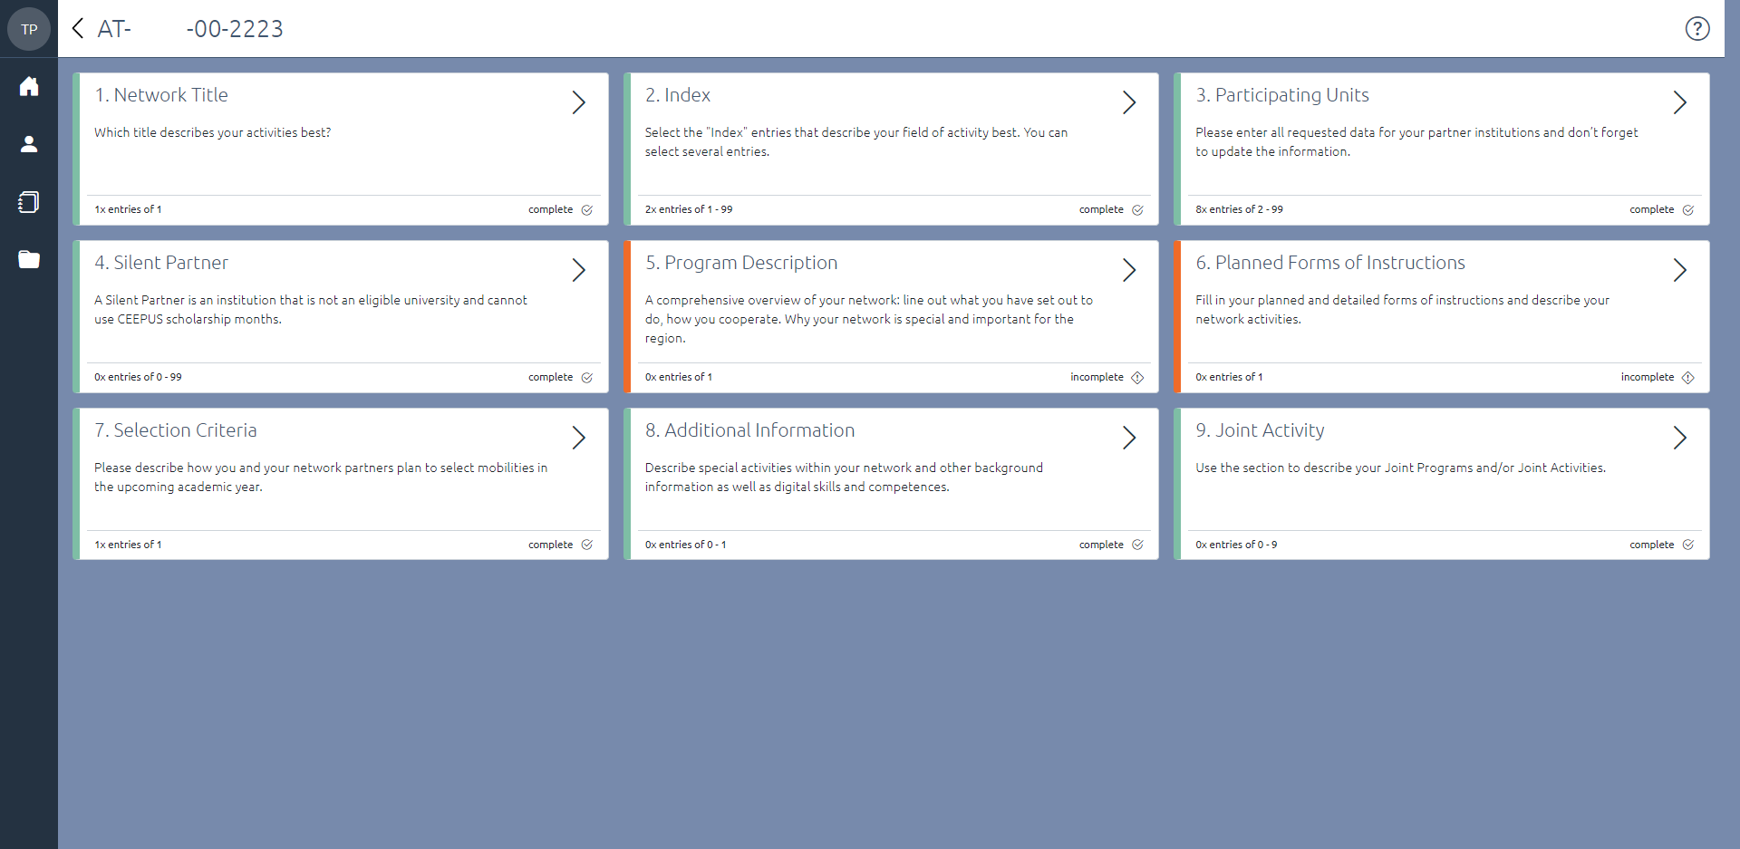

If you click on the back arrow you will get to the following overview
In this view you can edit the entries of the network request at any time by clicking the Edit button. If you click the Submit button, the network application is submitted, and further processing is no longer possible.
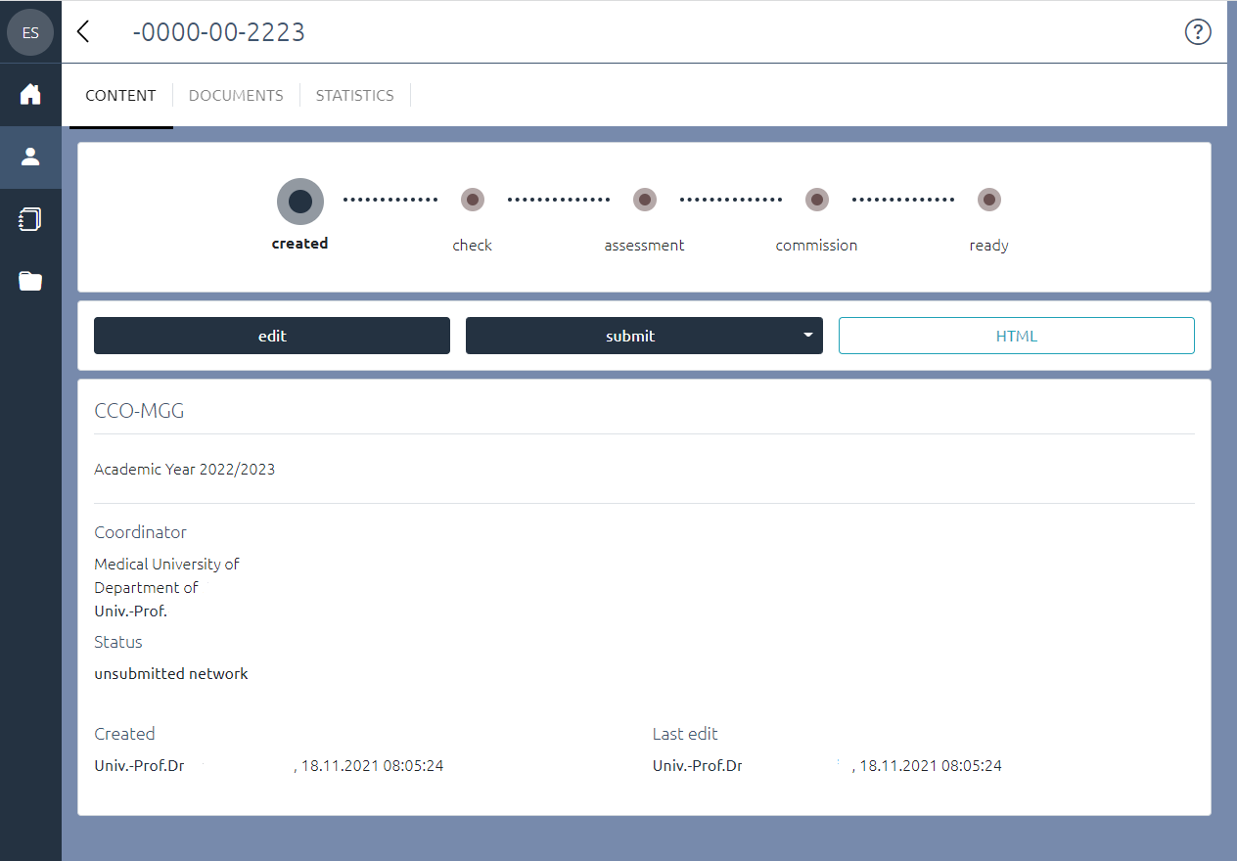
Important Deadlines:
Submission deadline: January 15, 2022
Document upload deadline: January 31,2022

